Test Case Table of Contents (Only Tests that Failed are Listed):

2 4 5 6 14 15 16 17 18 19 20

Resolved Test Cases:

2 4 5 6 14 15 16 17 18 19 20

**(SUCCESS!) Test Case 1: All inputs are valid (1 cart item)**

Results:

* Order was successfully added to the DB

Comment: Saan napupunta yung quantity and product name?

**RESPONSE: Meron Line Items table sa database which links the products and the orders. It’s not yet implemented cause wala pang laman ung database. And di ko pa alam pano gumamit foreign keys.**

**(SOLVED)Test Case 2: All inputs are valid (2 cart items)**

Results:

* Same window is used after “Add Order” was clicked once for the previous test case
* First row of cart is blank
* First cart item is put on second row
* 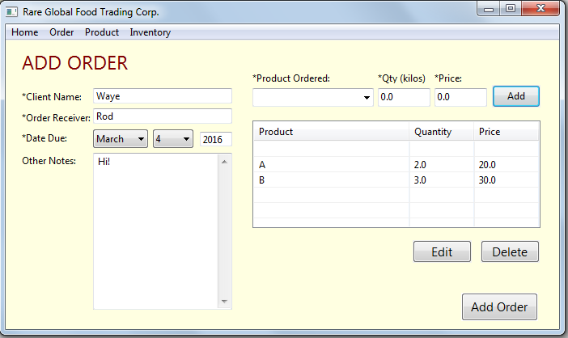
* Clicking “Add Order” results to an error on Eclipse
* 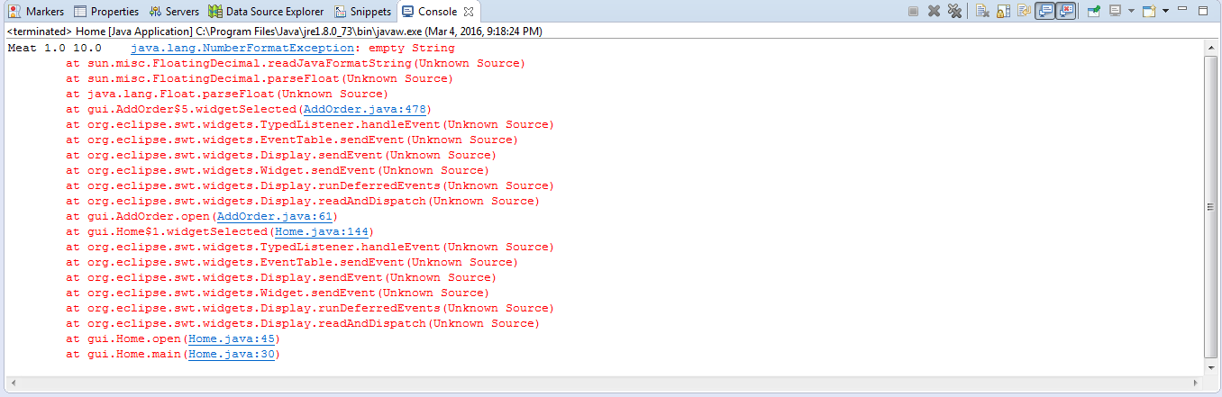
* No data was added to the orders_table
* App crashes

**(SUCCESS!) Test Case 3: All inputs are valid (2 cart items, app is restarted)**

Results:

* Order (the two cart items + details) was successfully added to the DB
* Purchase_orderID increments properly in the DB

**(SOLVED)Test Case 4: All inputs are valid (2 cart items)**

Results:

* Same window is used after “Add Order” was clicked once for the previous test case
* Same results with Test Case 2 but with two blank rows
* 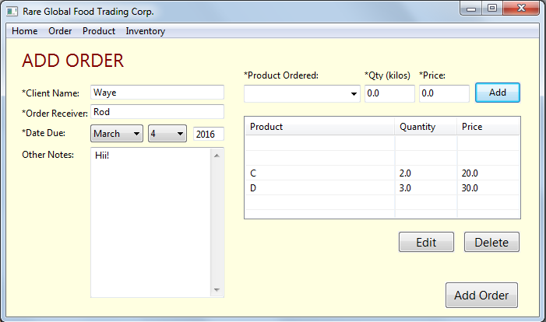

**(SOLVED)Test Case 5: Test Case 4 is recreated, the blank row is tried to be edited and deleted, and all inputs are valid**

Results:

* Blank rows can be edited
* Blank rows can be deleted
* Order is successfully placed in the DB

**(SOLVED)Test Case 6: All inputs are valid, but client name field is left blank (window from the previous test case is used)**

Results:

* Product is successfully added to cart
* Order is successfully placed in the DB, but the client name is left blank
* 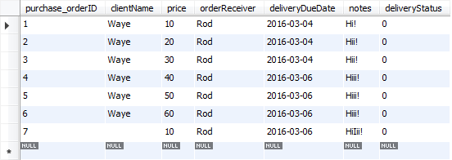

**(SUCCESS!) Test Case 7: All inputs are valid, but product name field is left blank**

Results:

* Add to cart is clicked
* Program asks to fill out all fields

**(SUCCESS!) Test Case 8: All inputs are valid, but quantity field is left blank**

Results:

* Add to cart is clicked
* Program asks to input a valid number

**(SUCCESS!) Test Case 9: All inputs are valid, but quantity field is entered with a symbol**

Results:

* Add to cart is clicked
* Program informs user that only numbers are allowed

**(SUCCESS!) Test Case 10: All inputs are valid, but quantity field is entered with a letter**

Results:

* Add to cart is clicked
* Program informs user that only numbers are allowed

**(SUCCESS!) Test Case 11: All inputs are valid, but price field is left blank**

Results:

* Add to cart is clicked
* Program asks to input a valid number

**(SUCCESS!) Test Case 12: All inputs are valid, but price field is entered with a symbol**

Results:

* Add to cart is clicked
* Program informs user that only numbers are allowed

**(SUCCESS!) Test Case 13: All inputs are valid, but price field is entered with a letter**

Results:

* Add to cart is clicked
* Program informs user that only numbers are allowed

**(SOLVED)Test Case 14: All inputs are valid, but order receiver field is left blank (window from the previous test case is used)**

Results:

* Product is successfully added to cart
* Order is successfully placed in the DB, but the order receiver is left blank
* 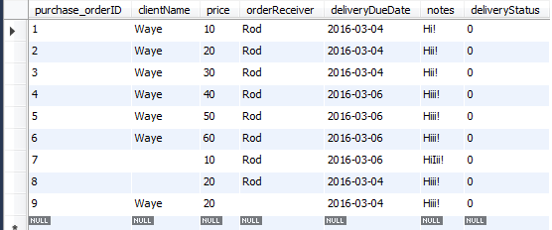

**(SOLVED)Test Case 15: All inputs are valid, but order receiver field is left blank (app is restarted)**

Results:

* Same result with Test Case 14

Comment: Hindi mo ata nachecheck yung sa left column (Names) nung app?

**RESPONSE: Mali pala kasi ung logic na nilagay ko dun sa if statement. Gumamit ako ng && instead of ||. Plus, di ko na instantiate ung strings as null.**

**(SOLVED)Test Case 16: All inputs are valid, but no month is selected for due date (window from the previous test case is used)**

Results:

* Program accepts the order, but no data is added to the DB

**(SOLVED)Test Case 17: All inputs are valid, but no day is selected for due date (window from the previous test case is used)**

Results:

* Program accepts the order, but no data is added to the DB

**(SOLVED)Test Case 18: All inputs are valid, but year field is left blank (window from the previous test case is used)**

Results:

* Clicking “Add Order” does not do anything

**(SOLVED)Test Case 19: All inputs are valid, but year field is entered with a symbol (window from the previous test case is used)**

Results:

* Clicking “Add Order” does not do anything

**(SOLVED)Test Case 20: All inputs are valid, but year field is entered with a symbol (app is restarted)**

Results:

* Clicking “Add Order” does not do anything
* Eclipse produces an exception but app does not crash
* 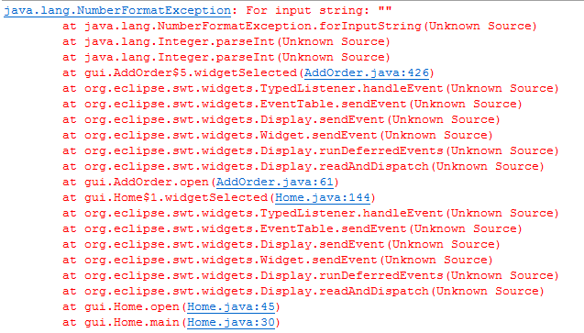

Comment: Same error rin ata sa previous year field tests pero hindi ko napansin na meron exception

**RESPONSE: Sa try-catch chinecheck if integer ung binigay ng user. Ipprint niya ung error sa console if hindi tapos magppop up ung error message.**